Micro Service
Restful Web Service also known as monolithic web service.
In Monolithic web service we need to develop all module which required for out project like Login Module, Customer Module, dashboard module, manager module, payment module etc.
Team 1 ----------------Login module
Team 2 -------------------Customer module
Team 3 -----------------------Payment module
We need to combine all those module, and need to create jar or war file and we need to deploy on production environment or actual server.
Limitation of monolithic web service
- Each team need to wait for all module to complete.
- If we need any features enhancement or any changes in existing module. We need to do change and re-deploy whole application once again.
- All these module must be develop using same language like Java or python or .net or php etc.
- We need to use only one database for whole application.

Micro Service : Micro Service is also type of rest full web service in this micro service rather than whole application we are develop small or tiny code, and those code can be develop using any other language base upon that language features as well as database and deploy independently with different port number.
In micro service is language independent, database independent and server independent and deploy independently in different port numbers.

To achieve micro service architecture in Spring boot spring boot provided two modules
- Sprint cloud
- Spring Eureka Server

Eureka Server is an open source server provided by Spring boot which help to deploy more than one micro service project develop using java or any other language. Eureka Server help us to register more than one micro service project and it check health of each micro service project.

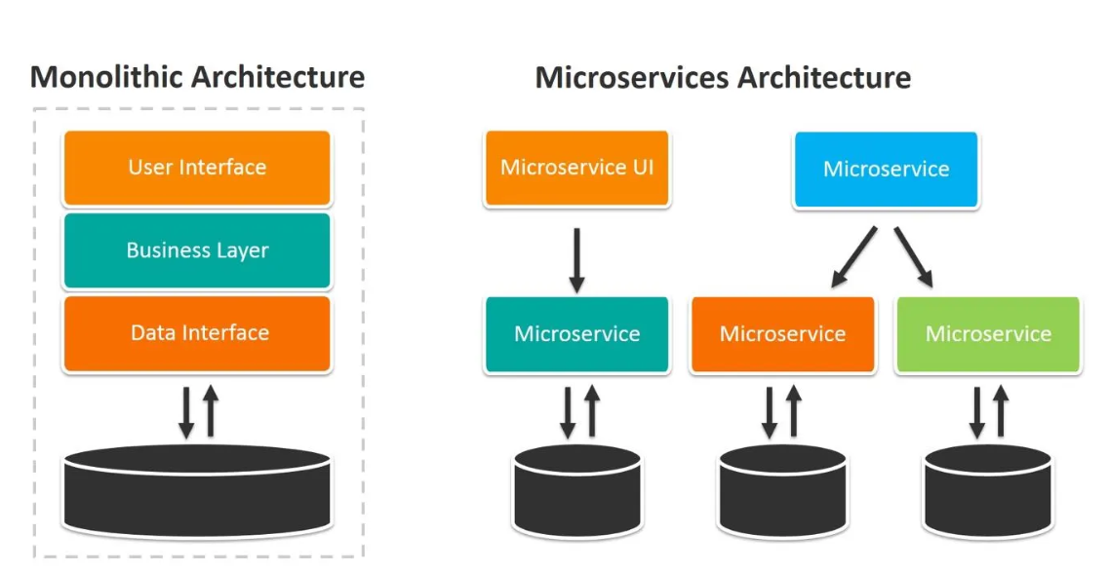

creating Eureka Server project using spring initializer

